**Implementation**

Throughout the project, efforts were made to make the design robust and suitable for daily use. The team considered using a PCB board to do this, but decided not to use it due to limited time and knowledge of PCB design. The fully working version of the circuit was tested in various simulation programs and then implemented. The location of the components was determined and optimum lengths were tried to be selected in terms of signal transmission. Heat sinks were adjusted by paying attention to thermal calculations, but the component positions on the stripboard could not be completed in time and soldered in a neat position due to limited time and the difficulties of pure analog design. Under these conditions, the overall circuit, rectifier - controller and output parts were positioned on separate pertinaxes and taken to the demo in this way.

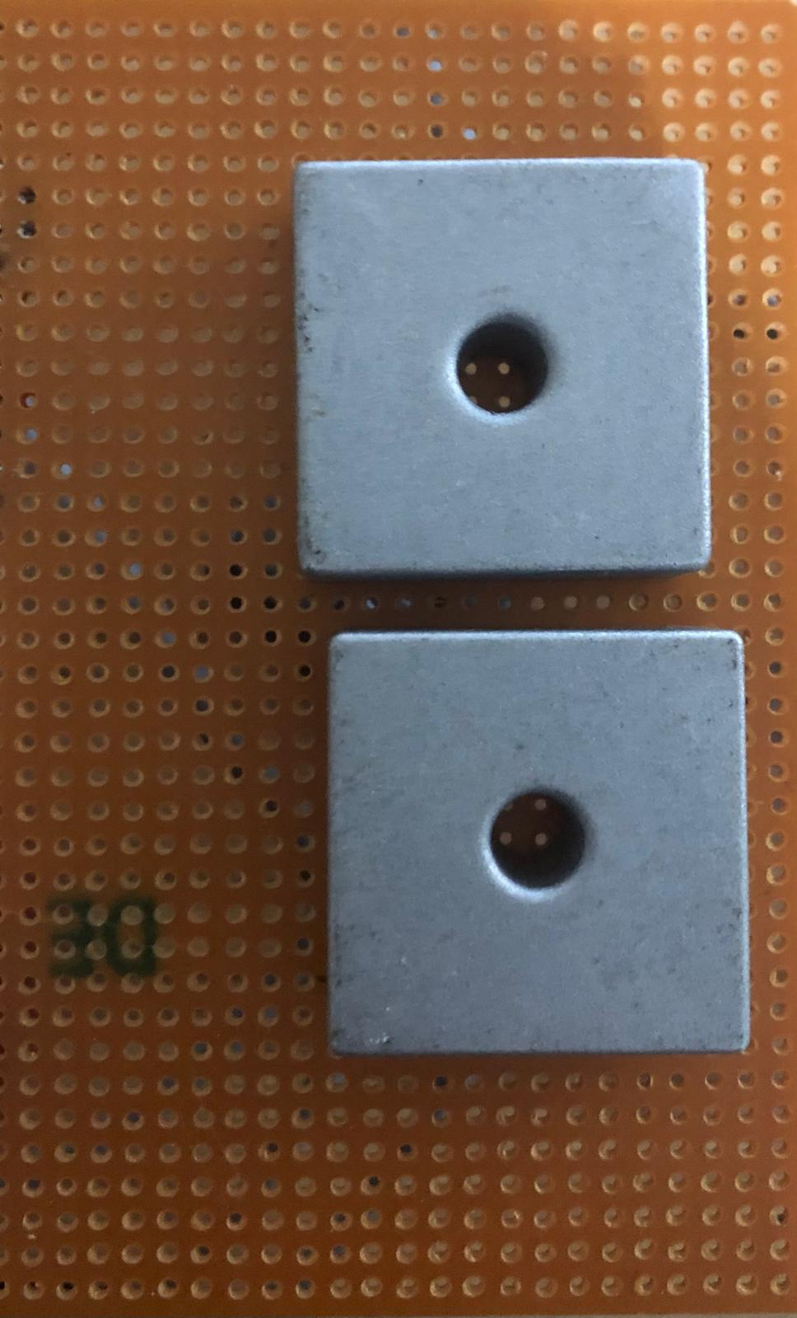 kablo, Elektrik kabloları, mühendislik, elektronik mühendisliği içeren bir resim

Açıklama otomatik olarak oluşturuldu

Figure a. Front and Back Side of Rectifier

Elektrik kabloları, elektronik mühendisliği, elektronik donanım, kablo içeren bir resim

Açıklama otomatik olarak oluşturuldu

Figure b. Front Side of Controller Part

Elektrik kabloları, elektronik mühendisliği, elektronik bileşen, devre bileşeni içeren bir resim

Açıklama otomatik olarak oluşturuldu

Figure c. Back Side of Controller Part

Elektrik kabloları, elektronik donanım, devre bileşeni, elektronik mühendisliği içeren bir resim

Açıklama otomatik olarak oluşturuldu

Figure d. Overall Charger Circuit